Katie Corry
Coordinating Seminar
Final Project – Surface Area of a Hand

Thesis:
Does the finding the surface area of an individual’s hand change the way we look at the Rule of Nines?
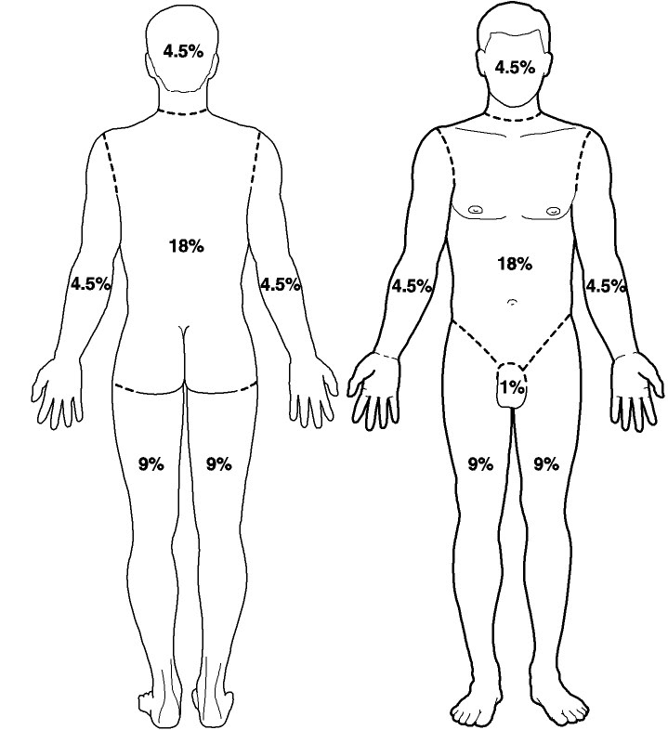
Rule of Nines and Burn Victims
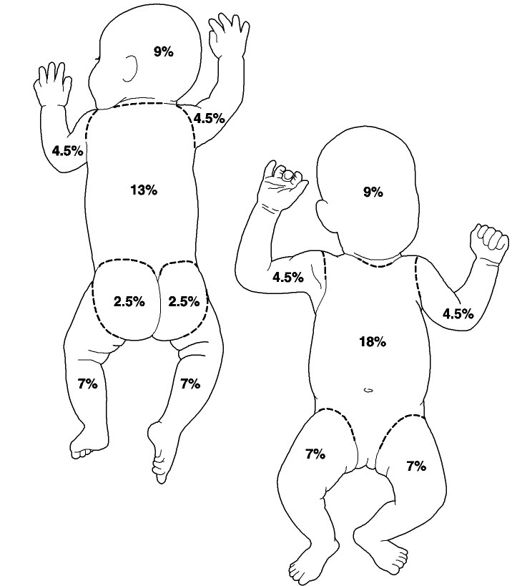

The rule of nines assesses the percentage of burn and is used to help guide treatment decisions including fluid resuscitation and becomes part of the guidelines to determine transfer to a burn unit. You can estimate the body surface area on an adult that has been burned by using multiples of 9.
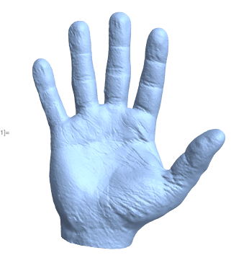
3D Hand
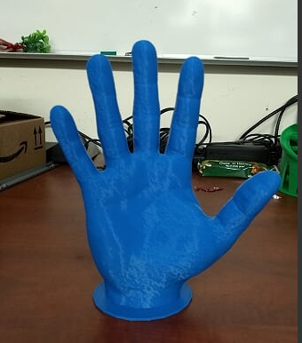

Factors to consider:
- Gender
- Age
- Weight
- Height
- Job
Measurement Techniques:
- Direct coating
- Triangulation
- Geometrically
- Linearly
- Surface Integration
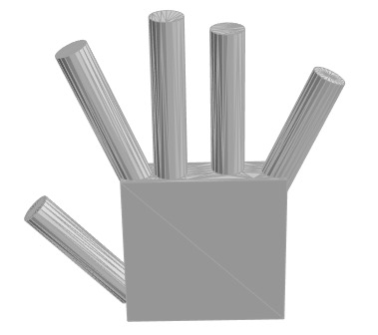
Geometrically:
Formulas:
Surface area of a cube:
A=2ab + 2bc + 2ac

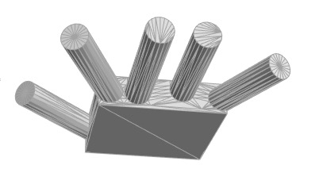
Surface area of cylinder:
A=2$Π$r²+2$Π$rh

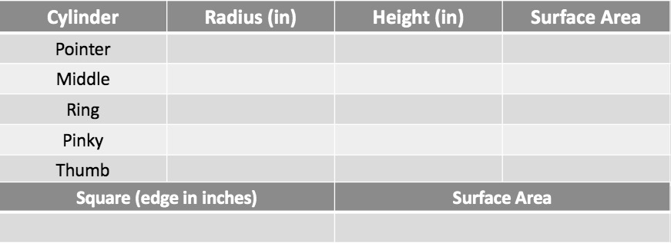

Total Surface Area (square inches):___________________

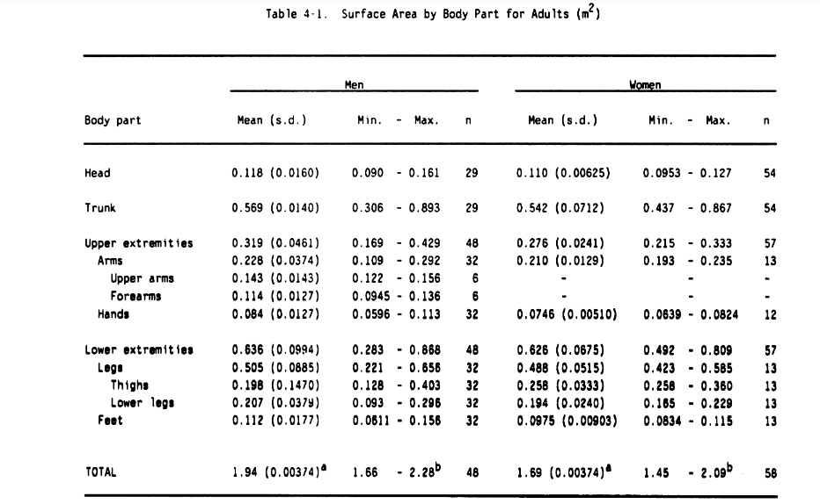
Linearly:

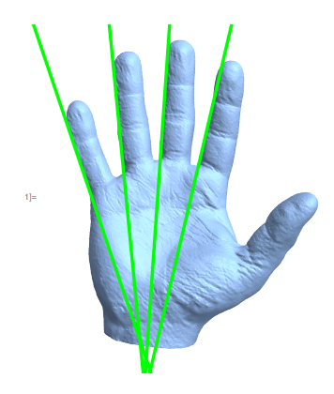
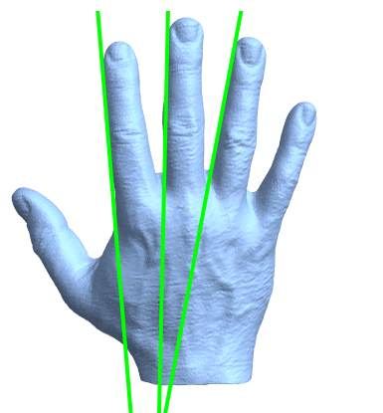
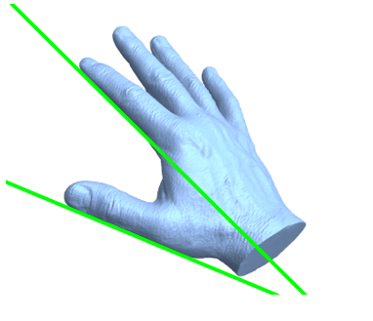

“A linear method has been proposed by DuBois and Dubois (1916) in which estimates are made on the principle that the surface area of the parts of the body are proportional, rather than equal, to the surface area of the solids they resemble. Estimates if surface area are made from lengths and circumferences are corrected by constants obtained from direct measurements of the surface area.”

Surface Integration:
Surface integration involves integrating a function over some surface in 3D space.

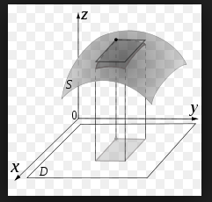

http://tutorial.math.lamar.edu/Classes/CalcIII/SurfaceIntegrals.aspx

3D Printed Skin:
http://www.cbsnews.com/news/how-3d-printing-could-revolutionize-burn-treatment/
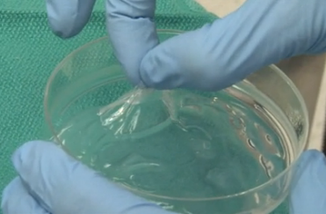
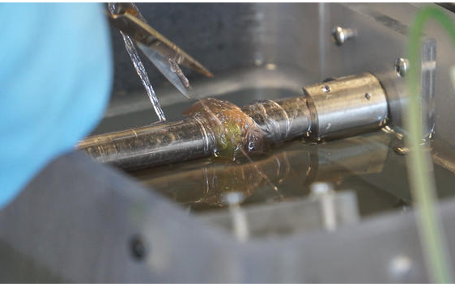

Works Cited

"Burn Percentage in Adults: Rule of Nines Chart." EMedicineHealth. N.p., n.d. Web. 02 May 2017.
http://www.emedicinehealth.com/burn_percentage_in_adults_rule_of_nines/article_em.htm

Lisi, Karen, Elaine Friebele, and Douglas A. Dixon. "Surface Area of the Human Body." Exposure Factors Handbook. By James J. Knoz. N.p.: n.p., n.d. 131-45. Print.

http://books.googleusercontent.com/books/content?req=AKW5QacAcQ_hKNATteAAJtLZtd6iZZ7UqZZb4w6xskF5yJGeK5SFUuCWy7qviuP7GCnmwUiYorhG_SNmLae_cPnZRGc17uy9uf1V4iHJ8XKqt61MGP2Tc6kniWspDQc1PdGDs-eopxz2tAqn2UAtGC__EZxbeiYl_t25RJm6uW4dnjBmFnkrNLOIiivF0rqoDahjOxXZLZlPlMNEfx-Y_3y_mb0o6rGKclWHCHk2kBuBCEOjiCsx3HBLkwFck1EQQjJpfq6hnS0k

