Name: _______________________________
Coordinating Seminar – Technology Presentation

Volumes of Solids of Revolution
Worksheet

The purpose of Volumes of Solids of Revolution is to find the volume of a given shape. This can be done by graphing the original function then rotating the graph around the x or y-axis. For our purposes we will be rotating our function around the x-axis while using the disk method to find the volume. It is important to keep in mind that the volume will always be positive and normally has the measurements units³.
The cool part about is, the 3D shape created can be exported to an stl file which then can be 3D printed.
Important Formulas:
$V=\int_{a}^{b}{A\left(x\right)dx}$ $A=πr^{2}$
*Note – We are using the volume of a circle formula because our method is disks and the radius is the function of the graph.

Example:
Find the volume of the solid obtained by rotating about the x axis the region under the curve y = $\sqrt{x}$ from 0 to 4.
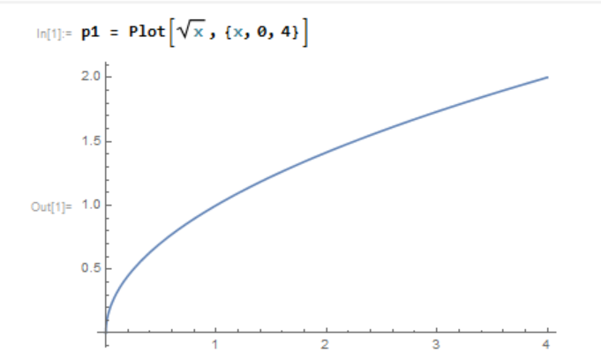
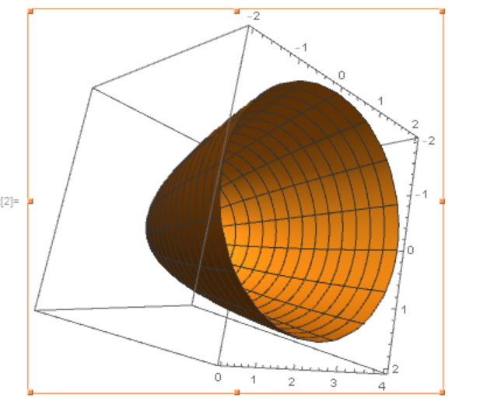

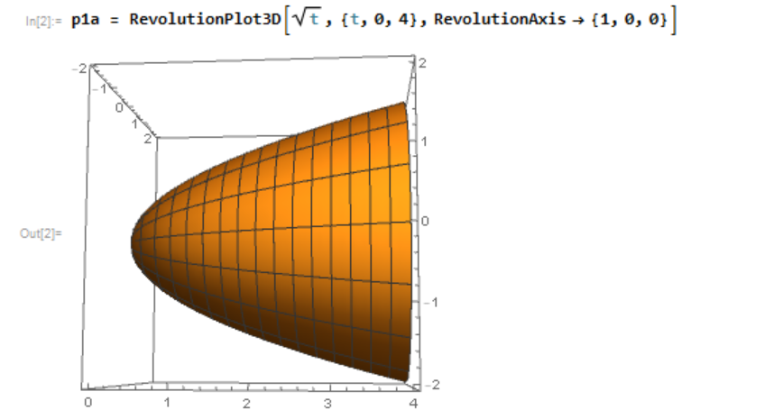
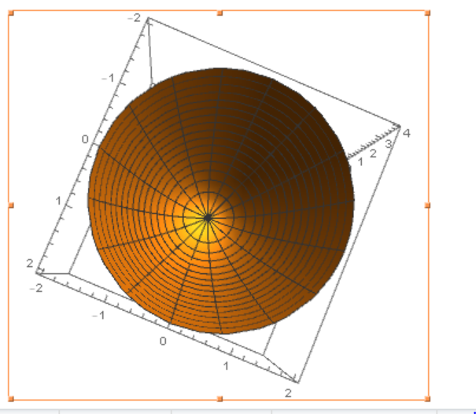

$V=\int_{a}^{b}{A\left(x\right)dx}$
$A=πr^{2}$
$r= \sqrt{x}$
$$A=π{(\sqrt{x})}^{2}$$
$$A=πx$$
$$V=\int_{0}^{4}{πx dx}$$
$$π\int_{0}^{4}{x dx}$$

4
$$π \frac{x^{2}}{2}$$
0

F(a) – F(b)
$π\left(\frac{4^{2}}{2}- \frac{0^{2}}{2}\right)$ = 8π units³

Check with Mathematica:
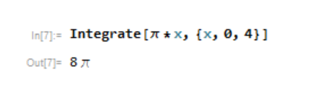

Where to find commands in Classroom assistance:
1. Open classroom assistance:

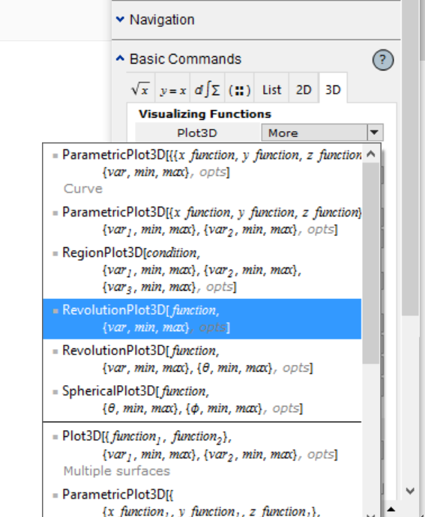
2. Plot Command: 3. 3D Plot Command
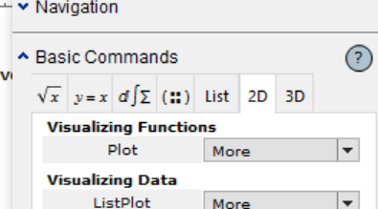

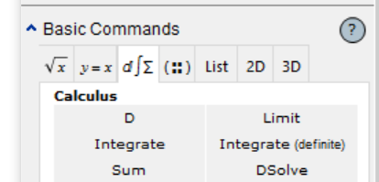
4. Integrate Command:

Exercise 1:

Find the volume of the solid obtained by rotating about the x axis the region under the curve y = -Cos(x) + 1 from 0 to π.
Step 1: Graph the function
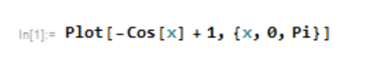

Tells Mathematica Range of function
to graph the function
Function

Step 2: Rotate the function
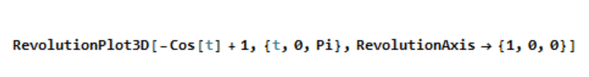

Tells Mathematica to Function Axis to rotate function
rotate function Range of {x, y, z}
function

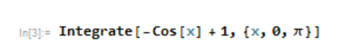
Step 3: Determine Volume

Tells Mathematica to Function Range of
integrate the function function
Solutions to Exercise 1:

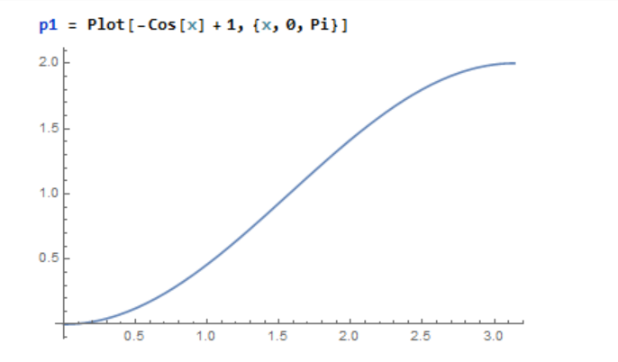
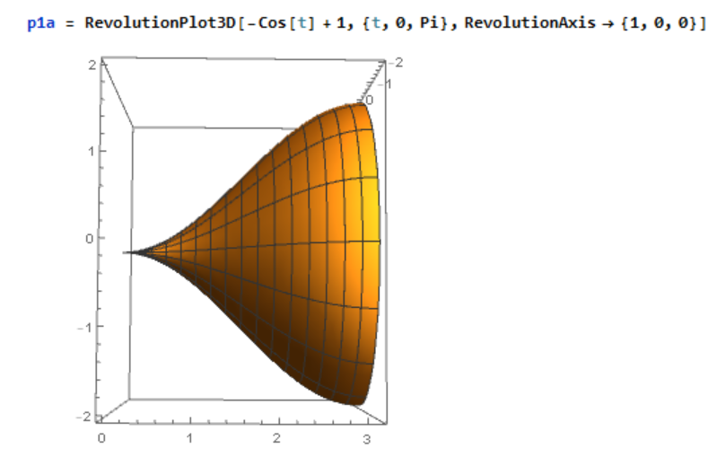
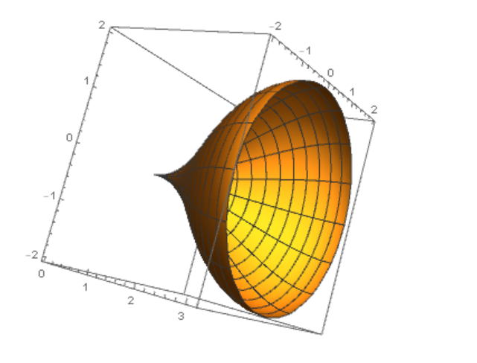

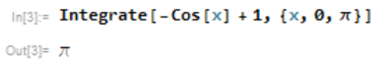
Practice Exercises:

1. Find the volume of the solid obtained by rotating about the x axis the region under the curve y= $Sin\left(-8x\right)\left(-π\right)$from 0 to 2$π$.

2. Find the volume of the solid obtained by rotating about the x axis the region under the curve y =$Sin(x)(-π)$from 2$π$. to -2$π$.

How to save 3D graph to stl file for 3D printing:
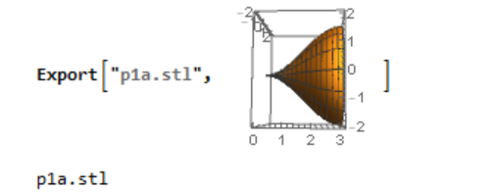

3D Software:
Blender
TinkerCad
Meshmixer
Maya
3D Tin

